Name _________________________________________

The storage tank system shown below is used to store process feedstock. Overfilling of storage tanks is a common problem in the process industries. To prevent overfilling, the storage tank is equipped with a high-level alarm and a high-level shutdown system. The high-level shutdown system is connected to a solenoid valve that stops the flow of input stock.

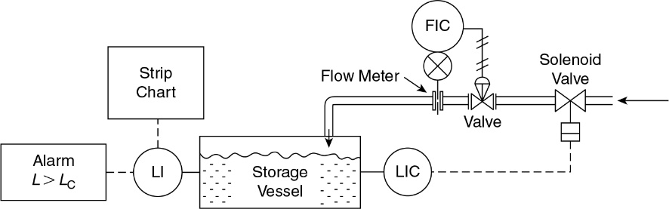

|  |  |  |  |
| --- | --- | --- | --- |
| **Component** | Failure Rate  Faults/year  *µ= -ln(R(t))* | Reliability  *R(t) = e -ut* | Probability of Failure  *P(t) = 1 – R(t)* |
| Control Valve | 0.60 |  |  |
| Level Measurement | 1.70 |  |  |
| Flow Measurement | 1.14 |  |  |
| Flow Switch (FIC) | 1.12 |  |  |
| Strip Chart | 0.22 |  |  |
| Indicator Alarm Lamp | 0.044 |  |  |
| Solenoid Valve | 0.42 |  |  |
| Storage Tank (leak) | 0.0086 |  |  |

What is the probability that the Solenoid Valve, Control Valve, and the Level Indicator Alarm (comprised of the level measurement and alarm lamp) will all fail together? What would be the failure rate and MTBF of this event?